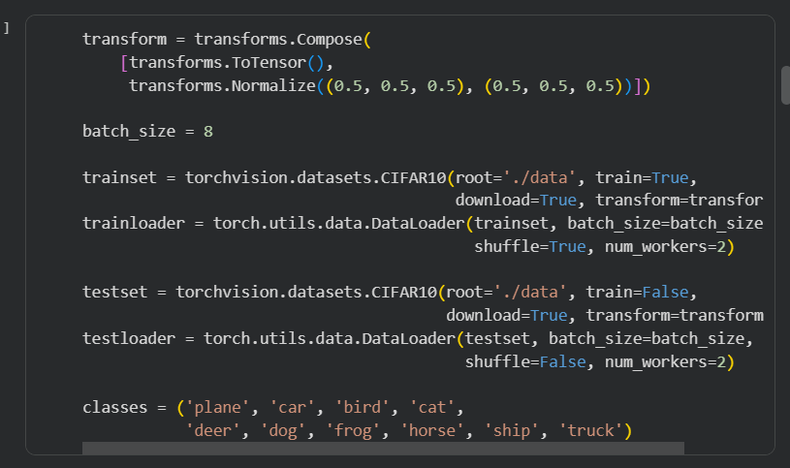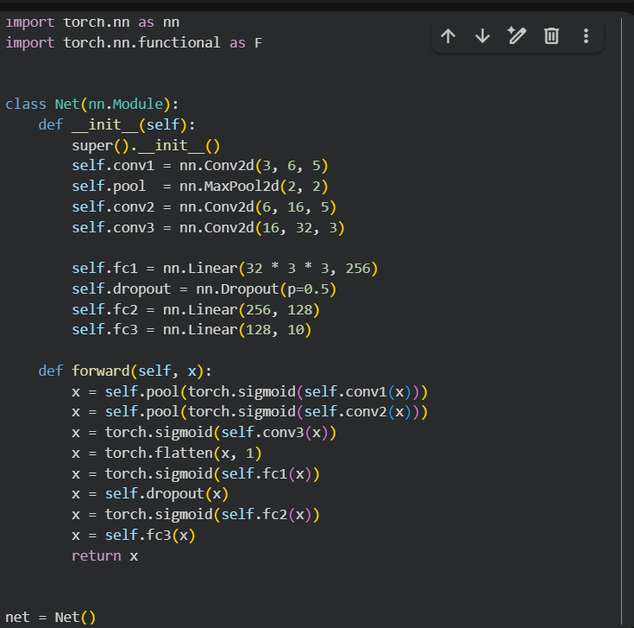

NET.PY
import torch.nn as nn
import torch.nn.functional as F

class Net(nn.Module):
def __init__(self):
super().__init__()
self.conv1 = nn.Conv2d(3, 6, 5)
self.pool = nn.MaxPool2d(2, 2)
self.conv2 = nn.Conv2d(6, 16, 5)
self.conv3 = nn.Conv2d(16, 32, 3)

self.fc1 = nn.Linear(32 * 3 * 3, 256)
self.dropout = nn.Dropout(p=0.5)
self.fc2 = nn.Linear(256, 128)
self.fc3 = nn.Linear(128, 10)

def forward(self, x):
x = self.pool(torch.sigmoid(self.conv1(x)))
x = self.pool(torch.sigmoid(self.conv2(x)))
x = torch.sigmoid(self.conv3(x))
x = torch.flatten(x, 1)
x = torch.sigmoid(self.fc1(x))
x = self.dropout(x)
x = torch.sigmoid(self.fc2(x))
x = self.fc3(x)
return x

net = Net()
